ML-CM.B

Extra large through-hole rotary hydraulic cylinder
- Matching for large bore power chucks.
- Special aluminum alloy steel body, light weight for reducing the spindle loading.
- Within check valves to maintain the thrust force.
- Extra large bore design, equipped with coolant collector and detective plate.
- The proximity switches and mounting bolts are extra option.
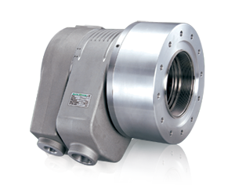
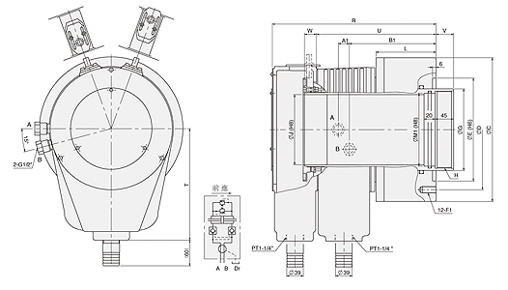
UNIT : mm
SPEC  Model | Piston  Dia.  (mm) | Piston Area  (cm²)  Push Side / Pull Side | Max. Draw Bar Force  KN(kgf)  Push Side / Pull Side | Piston  Stroke  (mm) | Max.  Operating  Pressure  MPa  (kgf / cm²) | Max.  Speed  (r.p.m.) | Moment  Of Inertia  I  (kg‧m² ) | Weight  (kg) | Total  Leakage  L/min
ML2814CM28B | 285 | 394 / 350 | 116.8(11910) / 106.8(10584) | 42 | 3.3(33.6) | 2000 | 1.08 | 87 | 11
ML2816CM28B | 285 | 394 / 350 | 116.8(11910) / 106.8(10584) | 42 | 3.3(33.6) | 2000 | 0.90 | 72 | 11
ML3320CM33B | 335 | 515.7 / 416.9 | 152.9(15591) / 136.9(13960) | 42 | 3.3(33.6) | 1600 | 1.09 | 103 | 14

DIM  Model | C | D | E  (H6) | G | H | J | L | R | T | U | V  max. | V  min. | W  max. | W  min. | A1 | B1 | F1 | M1
ML2814CM28B | 335 | 280 | 240 | 190 | M158x3.0 | 145 | 140 | 382 | 260 | 279 | 41 | -1 | 67 | 25 | 18 | 202 | M16x32L | 150
ML2816CM28B | 335 | 280 | 240 | 190 | M180x3.0 | 166.5 | 140 | 382 | 260 | 279 | 41 | -1 | 67 | 25 | 18 | 202 | M16x32L | 170
ML3320CM33B | 390 | 320 | 240 | 230 | M215x3.0 | 205 | 147 | 392 | 260 | 292 | 41 | -1 | 67 | 25 | 18 | 210 | M20x32L | 210

